Certificate of Recognition

“Amazing Person”

The Rotary Club of “YOUR CLUB” will donate $50, in your honour, to Yinka’s Coco Challenge so that 50 children can be vaccinated.


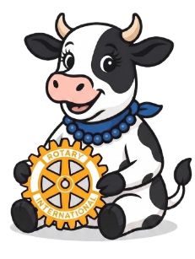
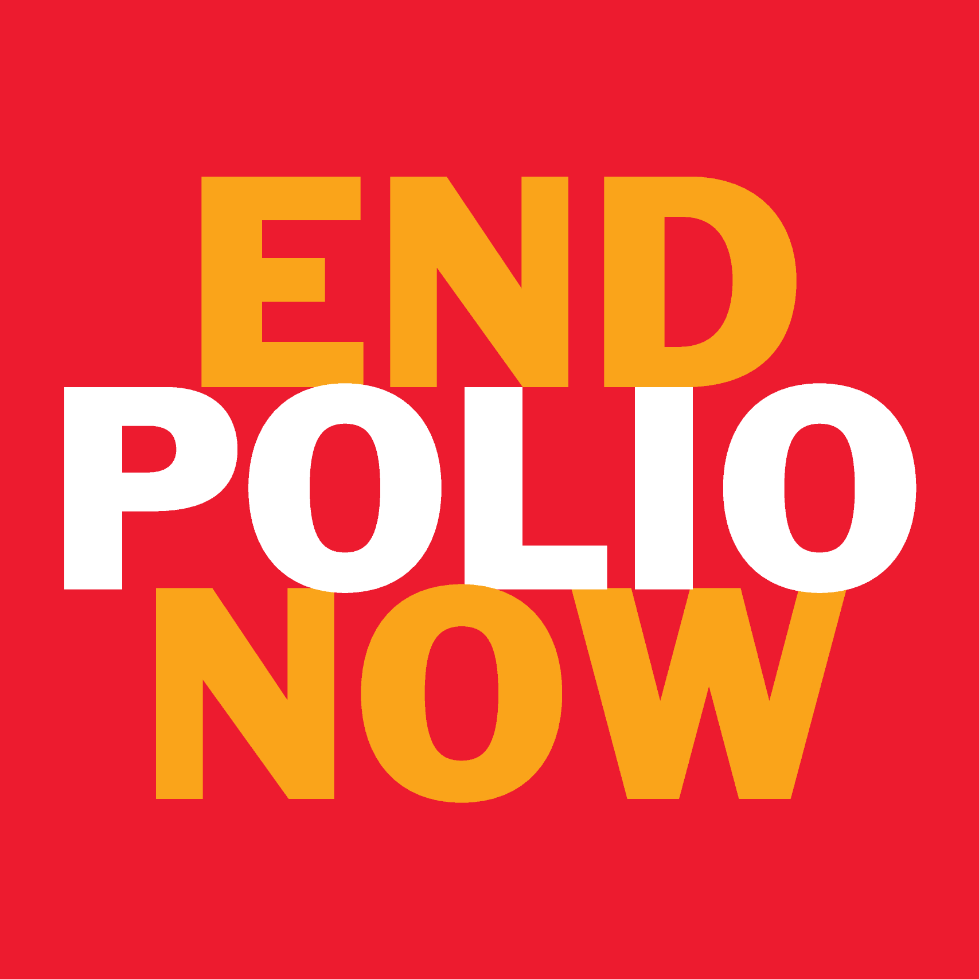
, 2026
________________________________ _____________________________
President Date

www.yinkascocochallenge.org @yinkas.coco.challenge

